K-2 Fitness Warm Up
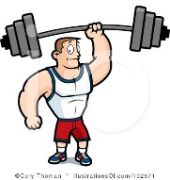
- Skip (1 min)
  - Freeze
- Gallop (1 min)
  - Freeze
  - Touch Toes
  - Arms over head/lean right/lean left
- Slide (1 min)
  - Freeze
  - Butterflies/R Leg in L leg out/L leg in R leg out
- Hop on 1 foot 5 time with R/L
  - Freeze
  - Balance on L/R
- Cherry Pickers
  - Freeze
  - Push up wave with R/L hand
  - Push up wave with R/L foot
- Jog
  - Freeze
  - Sit up 5 times with arms over head to touch toes
  - Stand up with no hands
- Walking Arm Circles
  - Freeze
  - R arm over L/L arm over R
  - R arm over head/L arm over head
  - Shake it out

